URL :- <http://cryptofairplay.freeart.co.il/>

1 CONTENT SHOULD NOT OVERLAP AND SHOULD BE VISIBLE

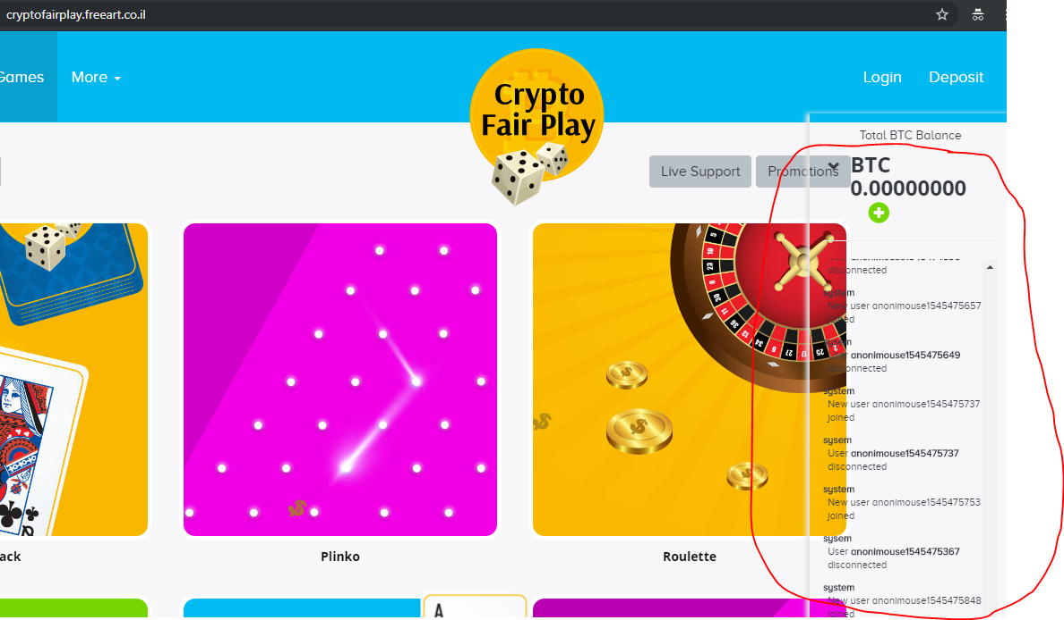

2 UNABLE TO GO BACK IN SELECTED PAGE

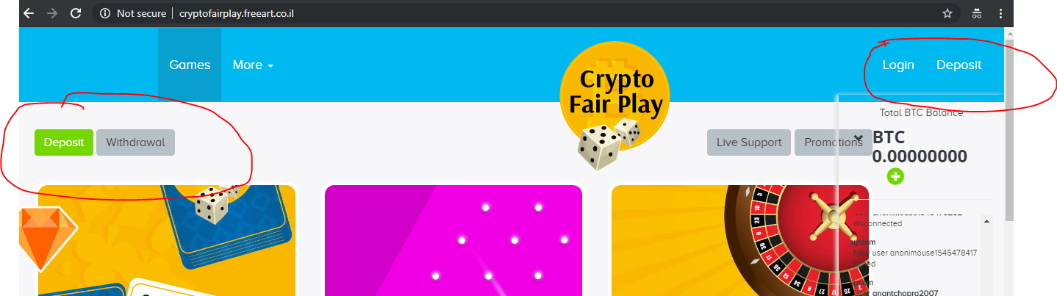

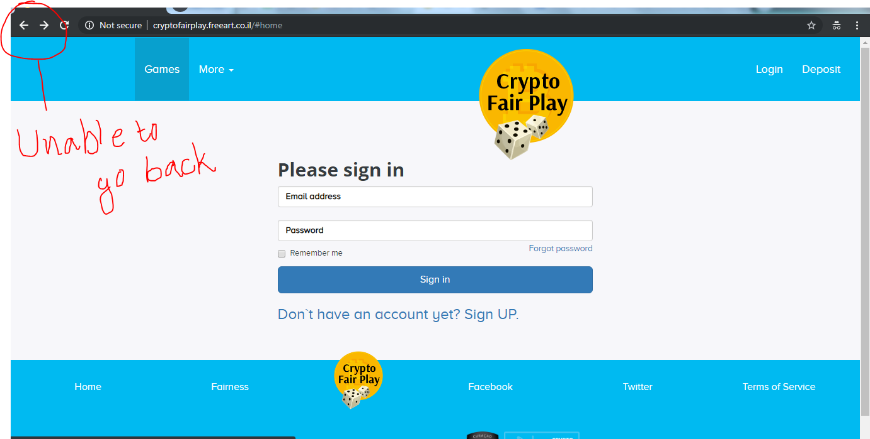

3 INCREASE VISIBILITY OF CONTENT

http://cryptofairplay.freeart.co.il/#fairness/overview

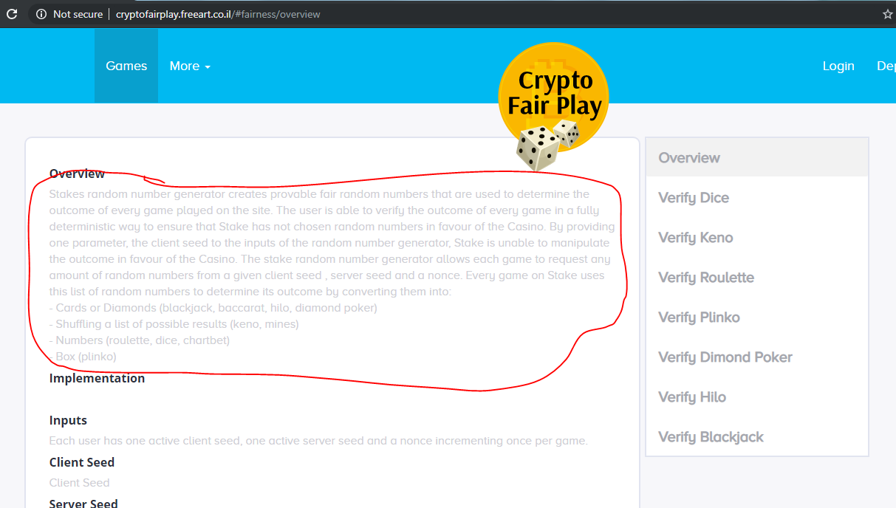

4 INCREASE VISIBILITY OF CONTENT

http://cryptofairplay.freeart.co.il/#terms-of-service

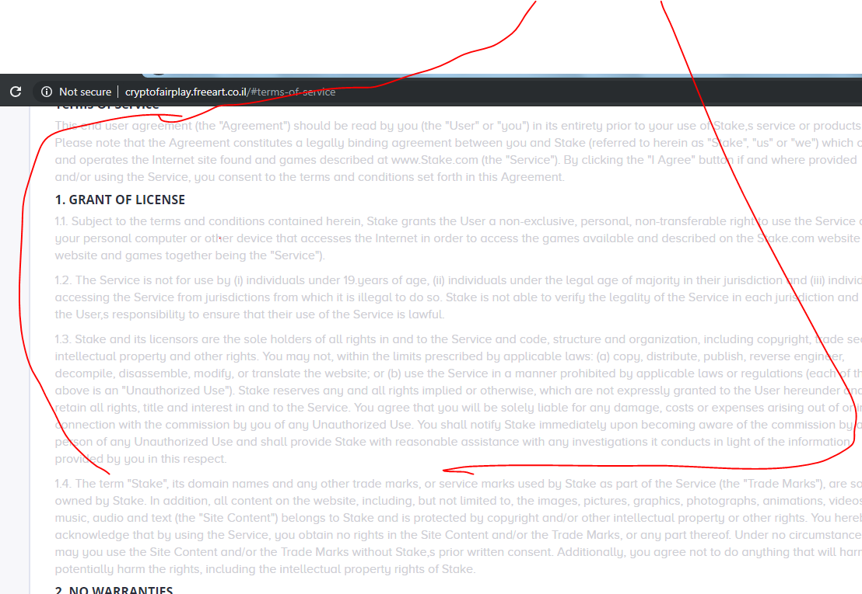

5 TITTLE OF THE PAGE SHOULD BE AS PER PAGE NAME

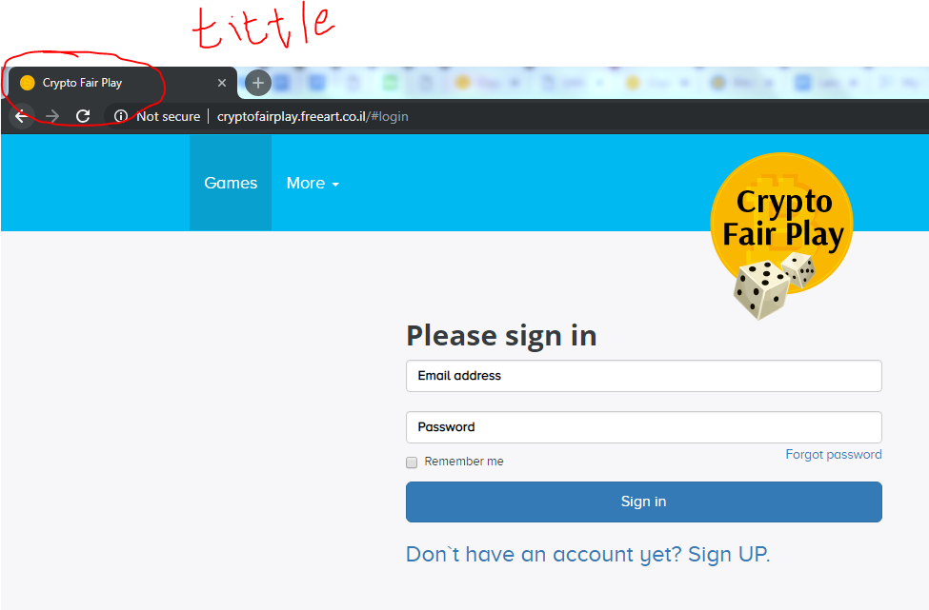

6 FIRST LETTER SHOULD BE IN CAPPITAL LETTER

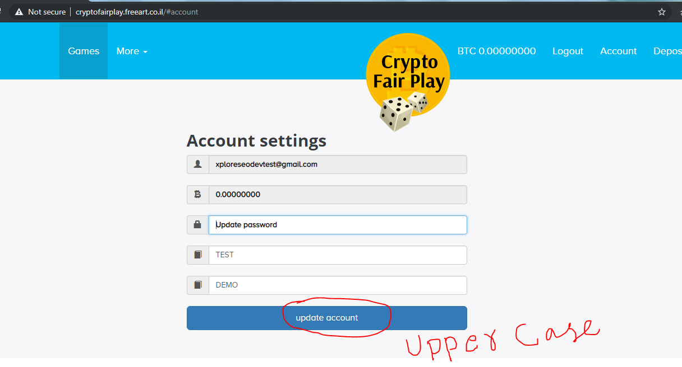

7 CONFIRMATION MESSAGE SHOULD BE COME AFTER “UPDATE ACCOUNT”

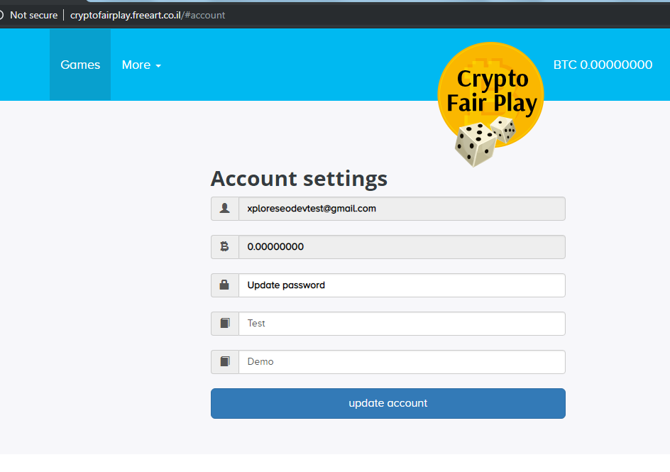

8 SELETED BUTTON IS NOT WORKING

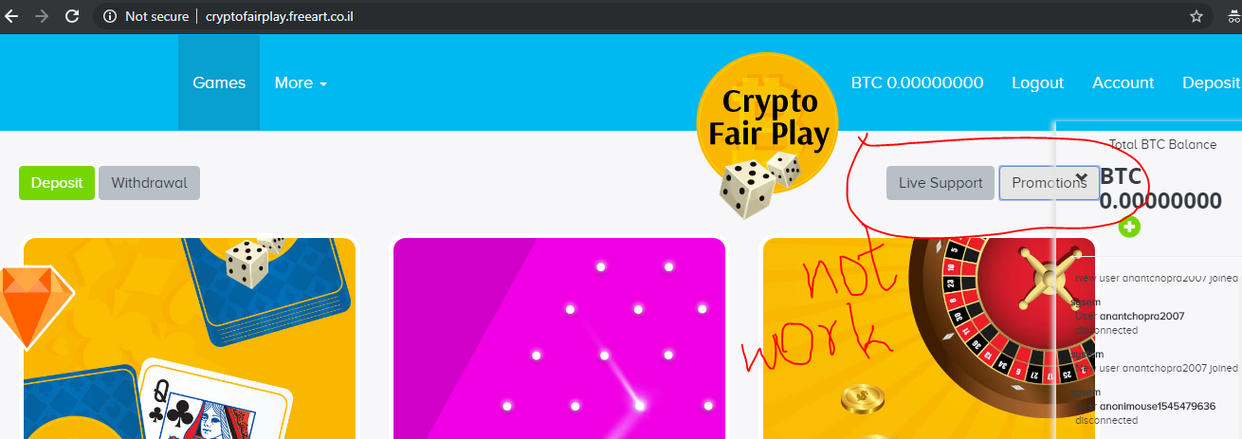

9 OPENED PAGE SHOULD BE COLORFUL

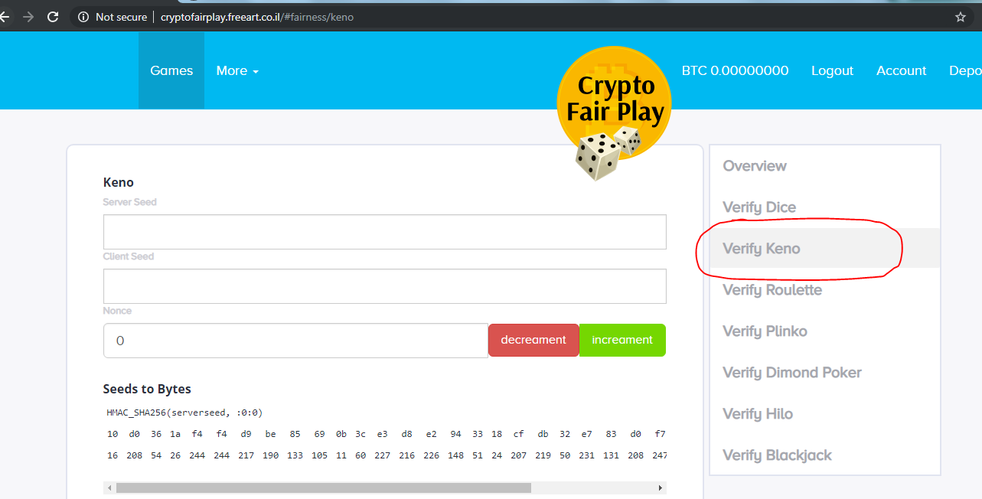

10 ALL CONTENT ARE OVERLAPED

<http://cryptofairplay.freeart.co.il/#fairness/dice>

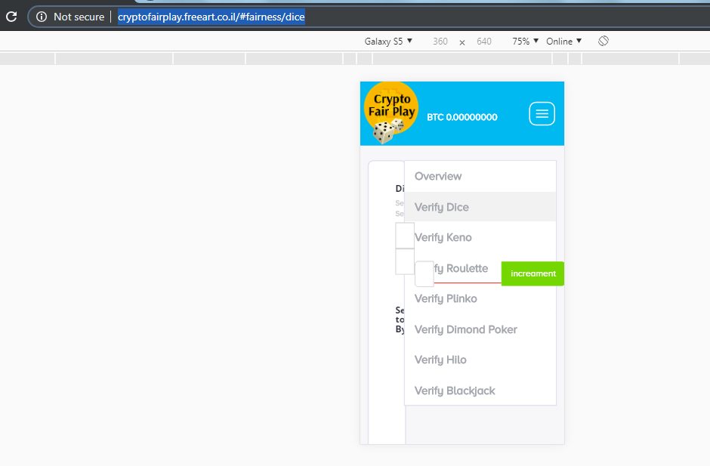

11 MENU BAR SHOULD BE CLOSED WHEN WE OPEN NEW PAGE

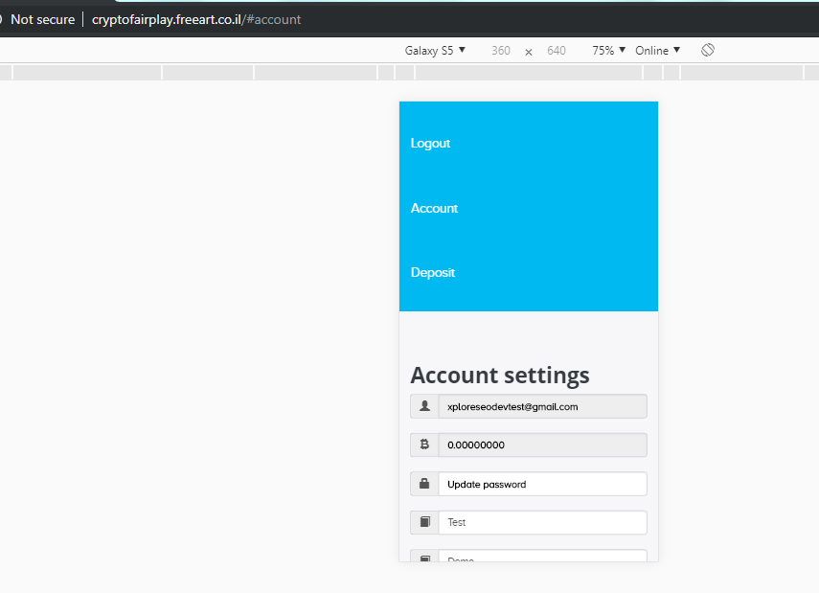

12 ICONS ARE BROKEN IN ACCOUNT PAGE

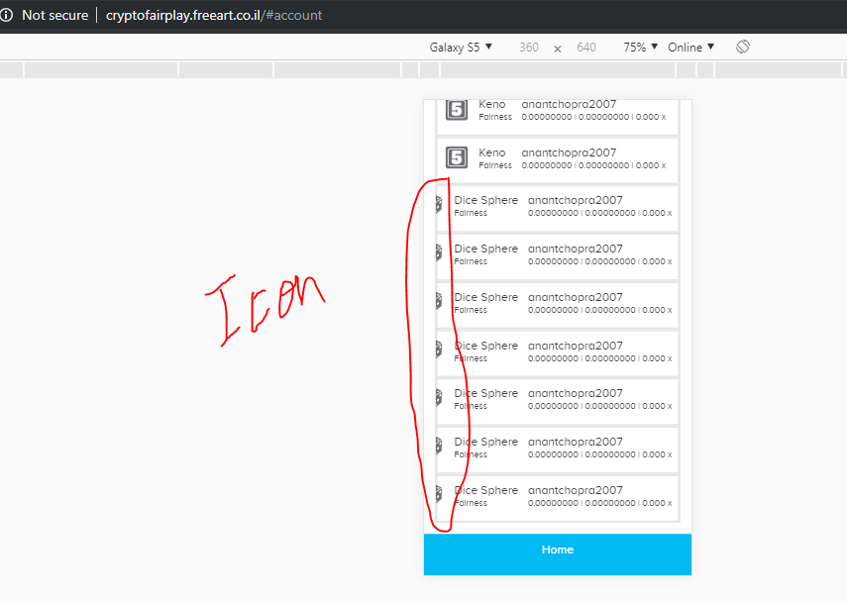

13 SELECTED COPY BUTTON IS NOT WORKING

<http://cryptofairplay.freeart.co.il/#deposit>

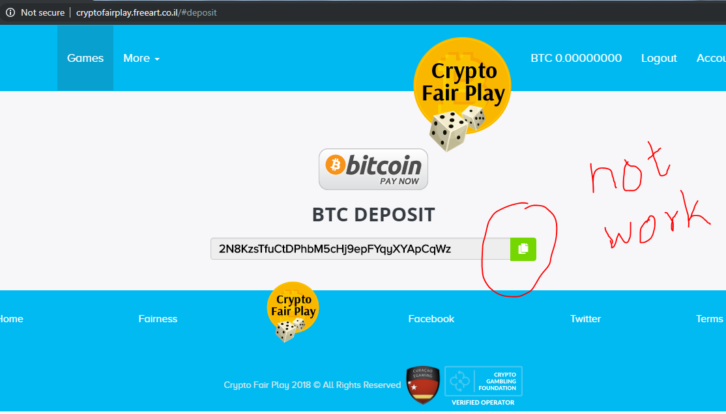

14 REMOVE GAP ON THE FOOTER

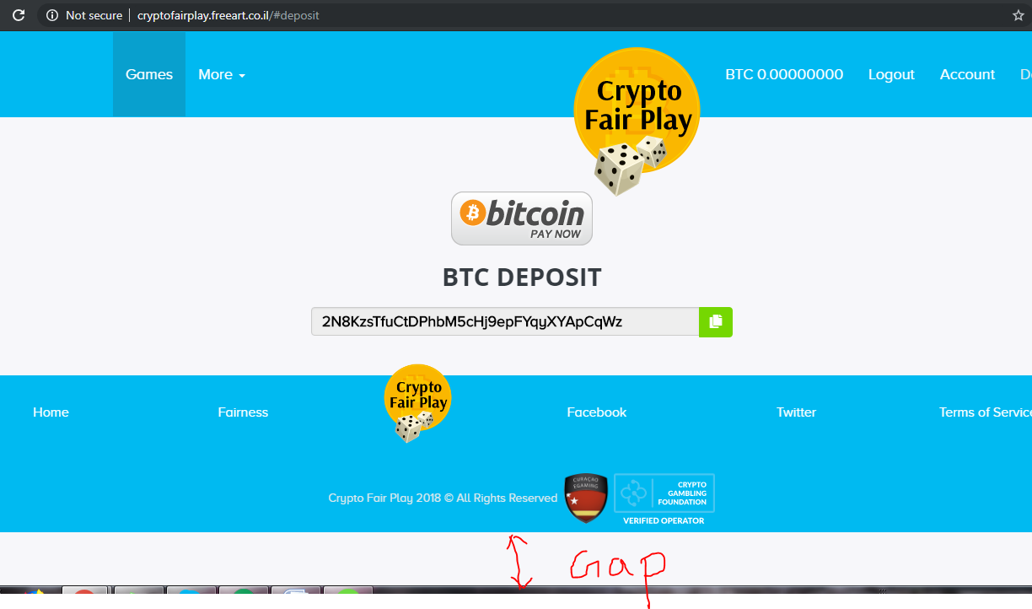

15 THERE SHOULD BE GAP (BETWEEN TWO GAMES ICON)

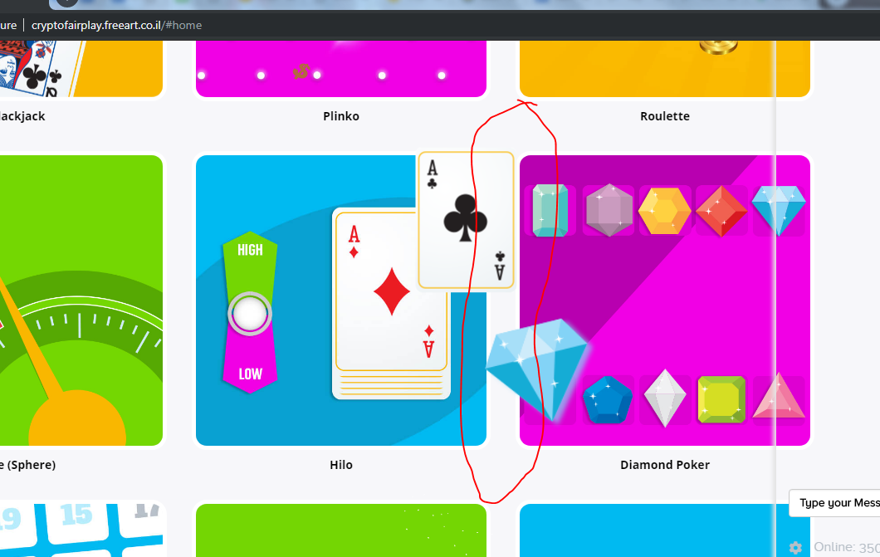

16 THERE SHOULD BE HEADING (SELECTED AREA) LIKE “TOTAL BALANCE”

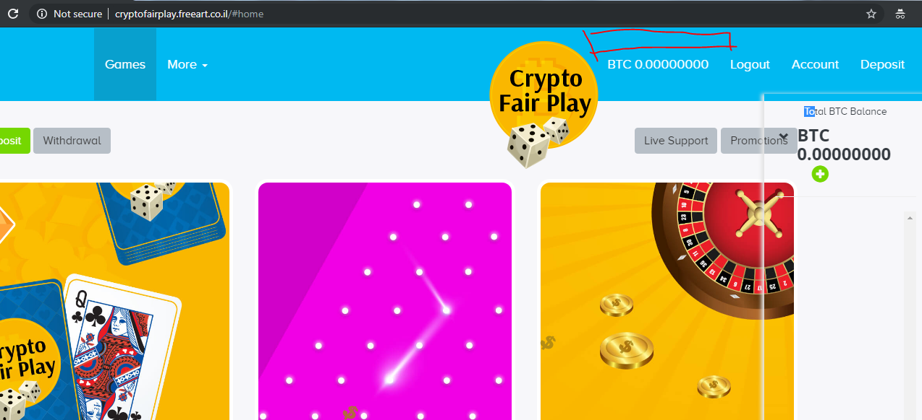

17 THERE SHOULD BE A “ PLAY “ BUTTON OR TEXT ABOVE ALL GAME ICON

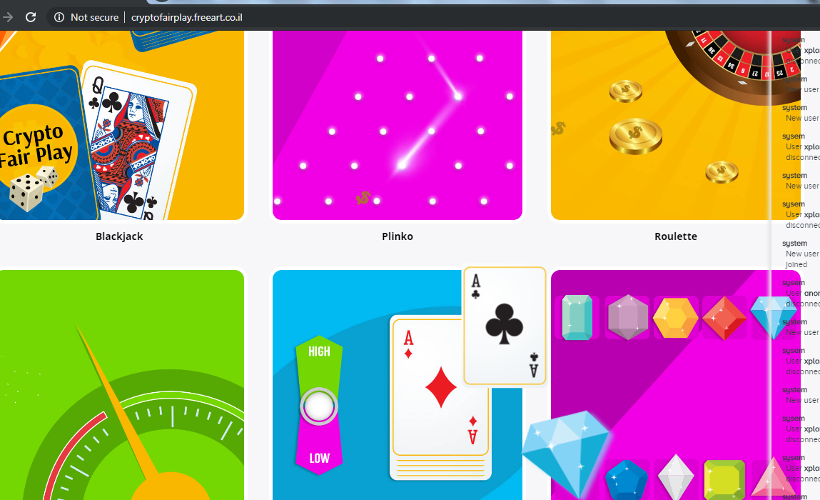

18 WHEN WE CLICK MORE BUTTON THEN IT LOOKS BOTH (GAMES & MORE) BUTTON ARE SELECTED

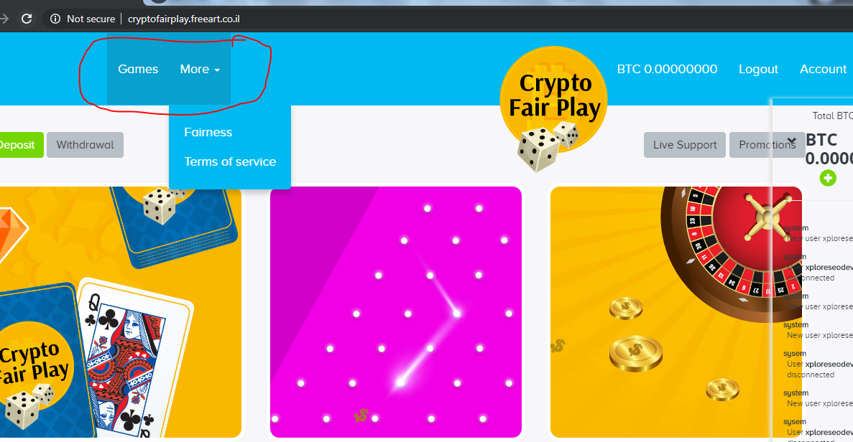

19 OPENED PAGE SHOULD BE SELECTED IN MENU BAR AND COLOR OF MODULE SHOULD BE CHANGE AFTER MOUSE HOVERING IN MENU BAR

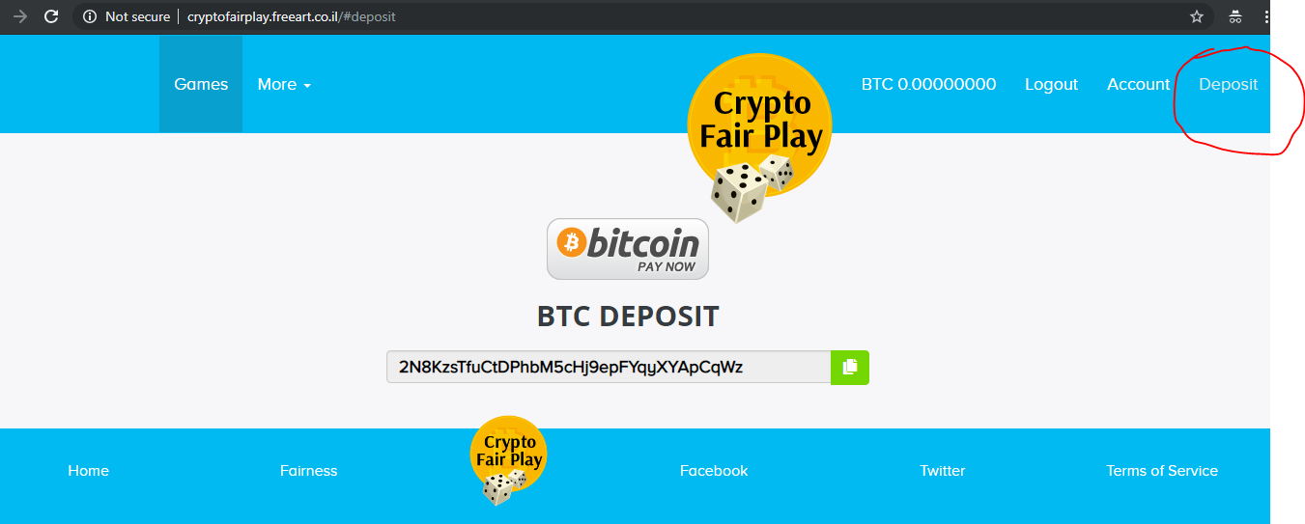

20 HEADER AND FOOTER ARE STRECHED AFTER “ZOOM IN”

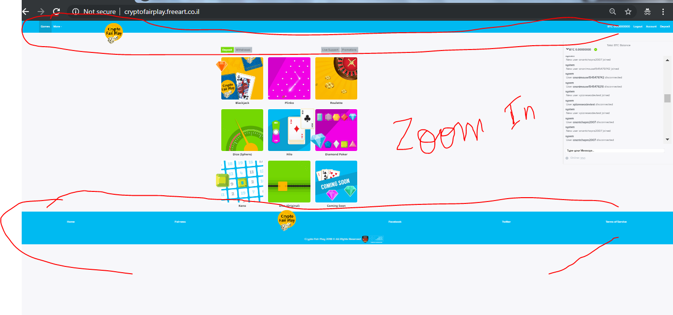

21 OVERLAPPING OF LOGO AFTER “ZOOM OUT”

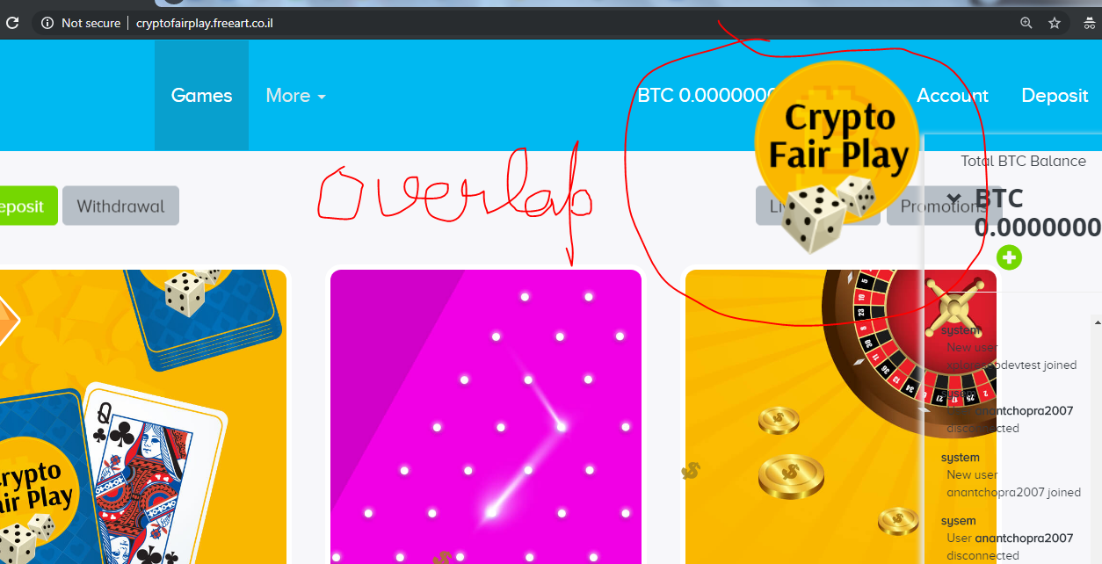

22 INNER PAGE OF ALL GAMES ARE NOT RESPONSIVE . I HAVE TO SCROLL LEFT TO CANCEL ERROR MESSAGE

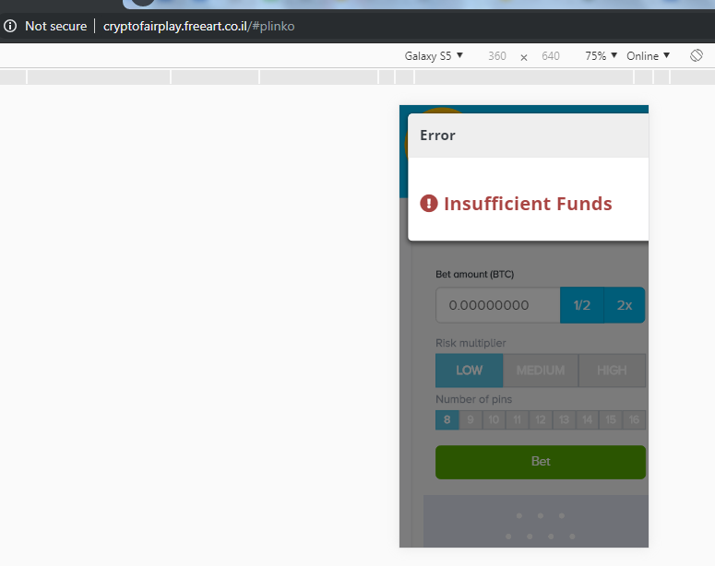

23 MOVE BOTH AND DOT IS MISSING IN COPYRIGHT

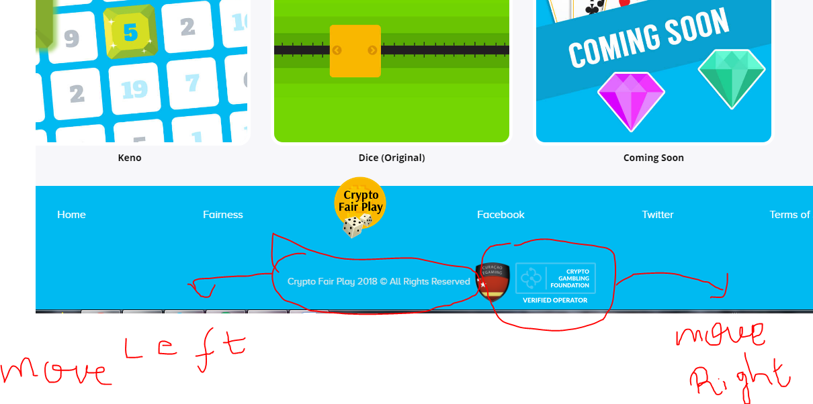

24 ALL IMPORTANT LINKS SHOULD BE PRESENT IN EVERY PAGE . EXAMPLE- CHANGE ANY GAME FROM ANY PAGE

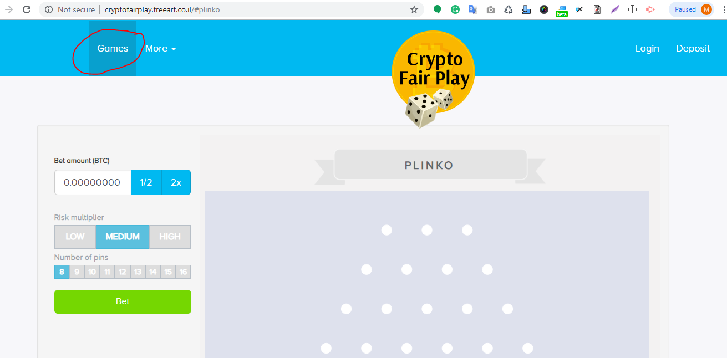

25 EVERY ICON CONTAINS TTTLE . EXAMPLE IS GIVEN BELOW

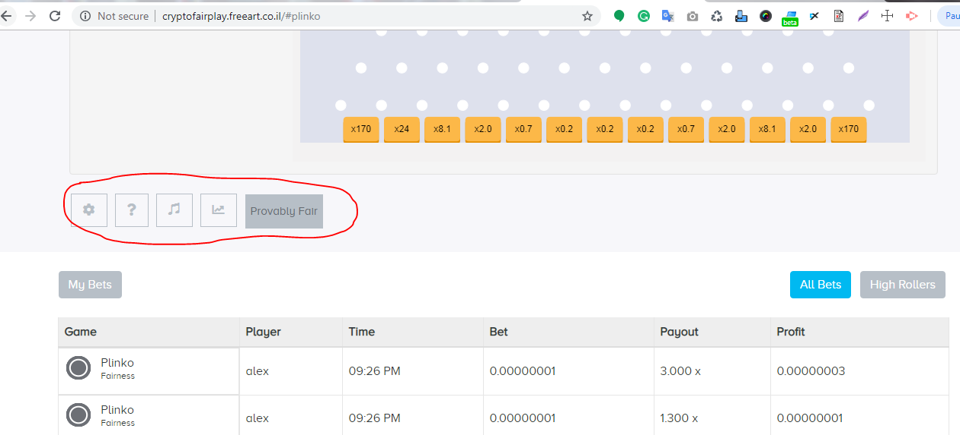

EXAMPLE :- SIMILAR TO THIS

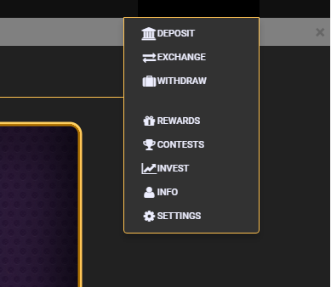

26 SUPPORT MAIL ID SHOULD BE THERE

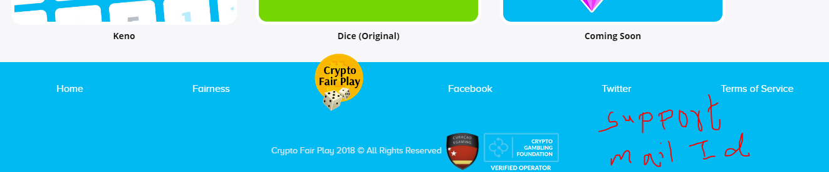

27 “LOGO” HIDING THE MESSAGE

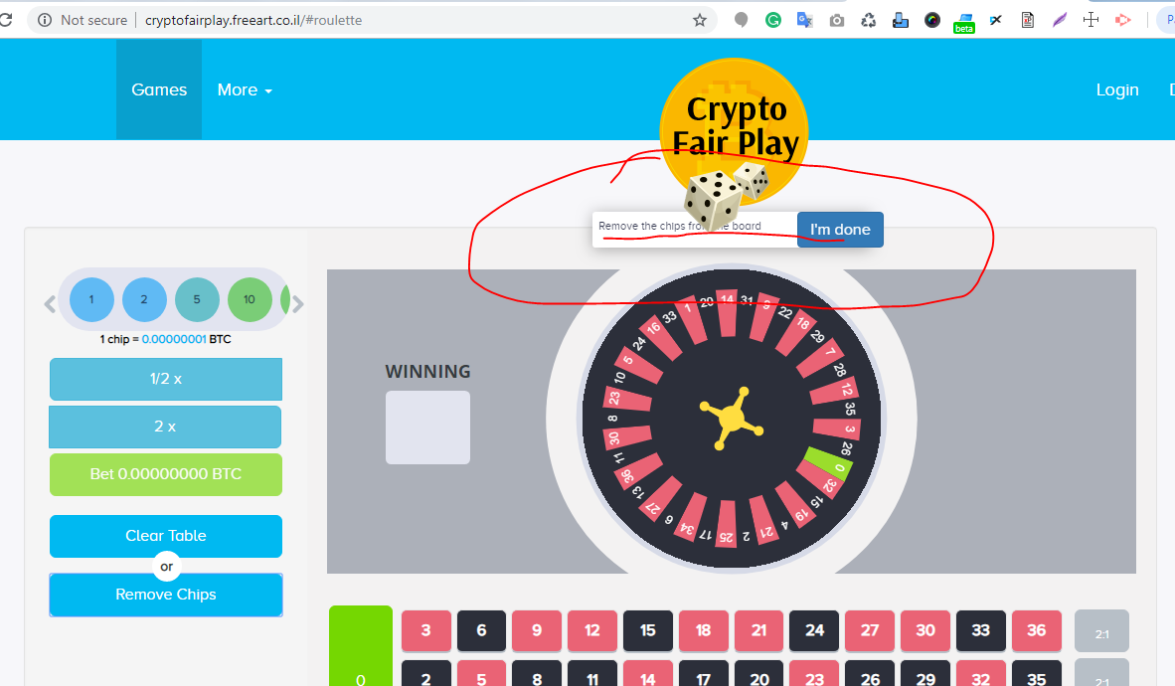

28 DID NOT GET MESSAGE THAT WE “WIN” OR “FAIL”

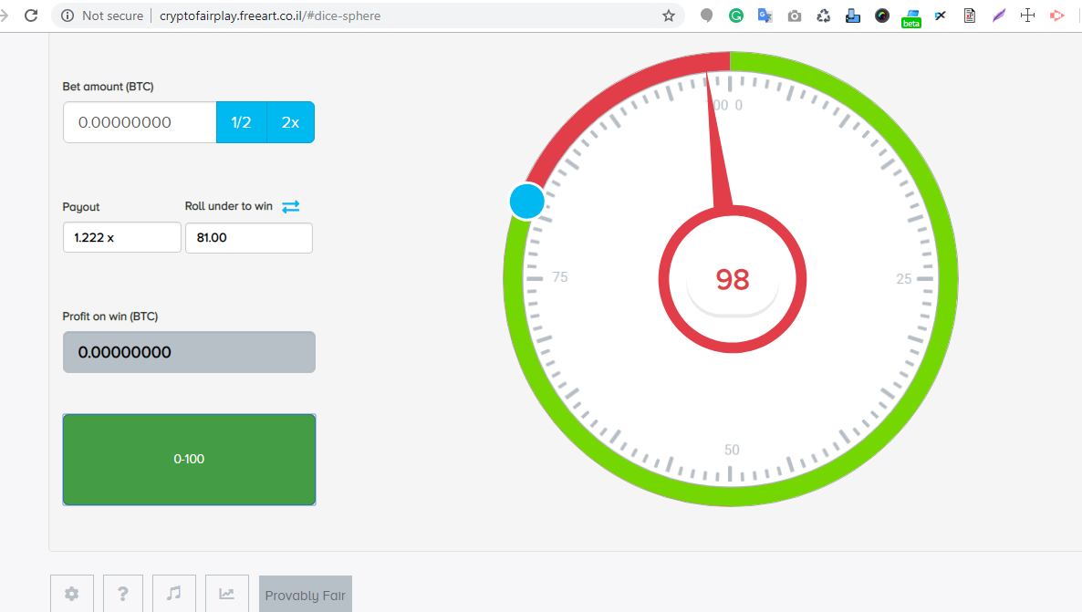

29 “READ MORE” BUTTON IS NOT WORKING

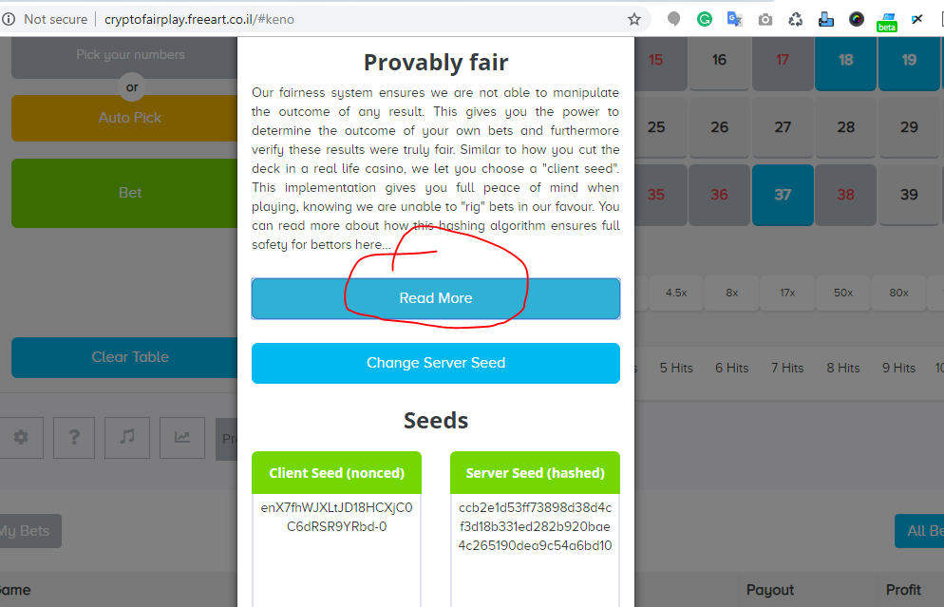

30 SELECTED BUTTONS ARE NOT WORKING IN MOBILE AND DESKTOP

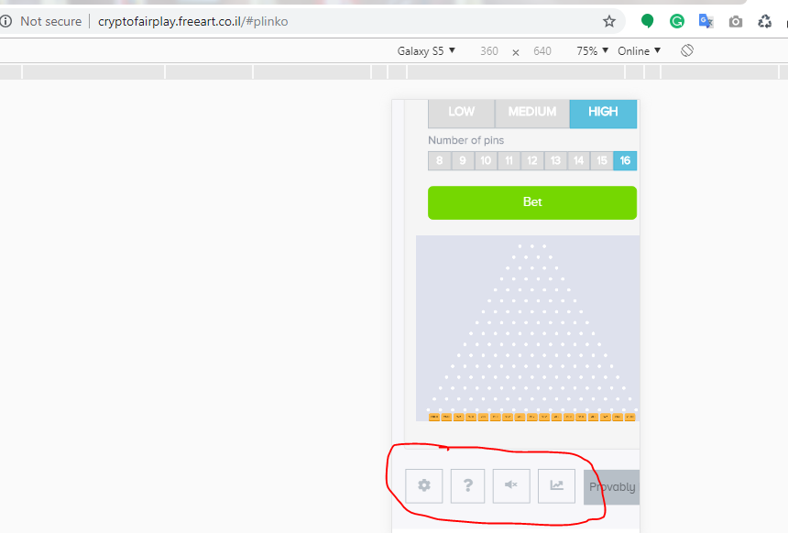

31